**EMPLOYEE MOVEMENT REQUEST WORK FLOW**

**RESIGNATION, RETIREMENT**

**EMPLOYEE** TO CREATE MOVEMENT AND SEND TO IMMEDIATE SUPERIOR FOR APPROVAL

(DISABLE ENTRY OF EFFECTIVITY DATE)

**IMMEDIATE SUPERIOR** TO APPROVE AND SEND TO DEPARTMENT HEAD FOR APPROVAL

**DEPARTMENT HEAD** TO APPROVE AND SEND TO HRD ASSISTANT FOR VALITDATION

**HRD ASSISTANT** TO VALIDATE, SET THE HR APPROVER, ENTER THE EFFECTIVITY DATE AND SEND TO HRD SUPERVISOR FOR REVIEW

**HRD SUPERVISOR** TO REVIEW AND APPROVE THE MOVEMENT REQUEST AND SEND TO HRD MANAGER FOR APPROVAL

**HRD MANAGER** TO VALIDATE AND APPROVE THE MOVEMENT REQUEST

Note: Any information for correction on movement request will be disapproved by HRD Supervisor or HRD Manager and request will go back to HRD Assistant for editing.

**EMPLOYEE MOVEMENT REQUEST WORK FLOW**

**PROMOTION, SALARY INCREASE, TRANSFER, ETC.**

**IMMEDIATE SUPERIOR** TO CREATE MOVEMENT REQUEST FOR THE EMPLOYEE AND SEND TO DEPARTMENT HEAD FOR APPROVAL

(DISABLE ENTRY OF EFFECTIVITY DATE)

**DEPARTMENT HEAD** TO APPROVE AND SEND TO COO FOR APPROVAL

**COO** TO APPROVE AND SEND TO HRD ASSISTANT FOR VALIDATION

**HRD ASSISTANT** TO VALIDATE, SET THE HR APPROVER, ENTER THE EFFECTIVITY DATE AND SEND TO HRD SUPERVISOR FOR REVIEW

**HRD SUPERVISOR** TO REVIEW AND APPROVE THE MOVEMENT REQUEST AND SEND TO HRD MANAGER FOR APPROVAL

**HR MANAGER** TO VALIDATE AND APPROVE THE MOVEMENT REQUEST

**OPTIONAL: GROUP ADMIN MANAGER** TO VALIDATE AND APPROVE THE MOVEMENT REQUEST

Note: Any information for correction on movement request will be disapproved by HRD Supervisor or HRD Manager or Group Admin Manager and request will go back to HRD Assistant for editing.

**EMPLOYEE MOVEMENT MOCKUP**

1. **EMPLOYEE MOVEMENT REQUEST**

**A1.1** -Immediate Superior will create employee movement (regularization) for his/her subordinates.

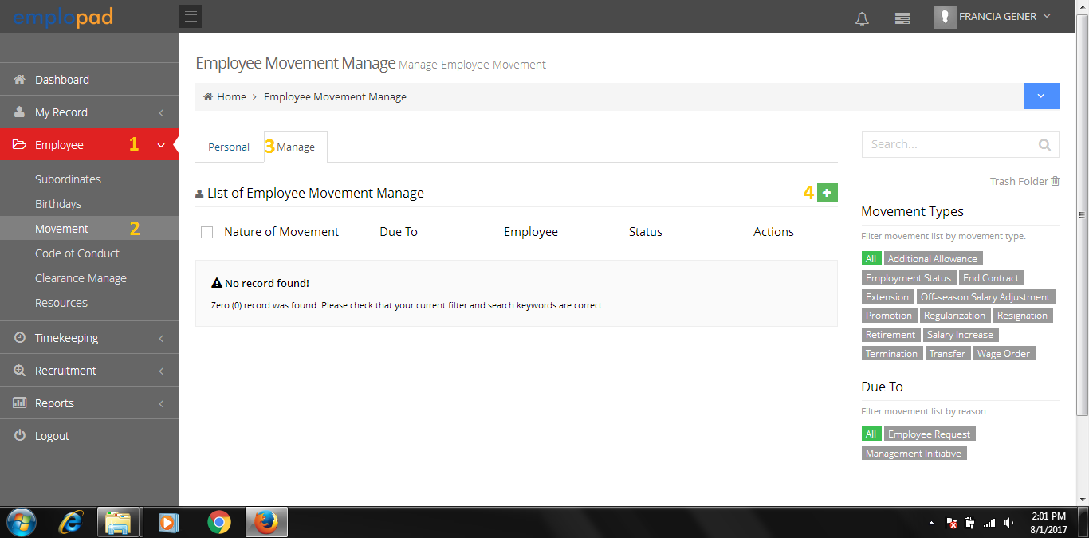

Personal Tab: will be used for the ff. movement type:

* Resignation
* Retirement

Manage Tab:

* Will be used by immediate superior for movement request of his/her subordinates.
* Can view all the movement request of subordinates.

**A1.2** -Select thetype of movement.

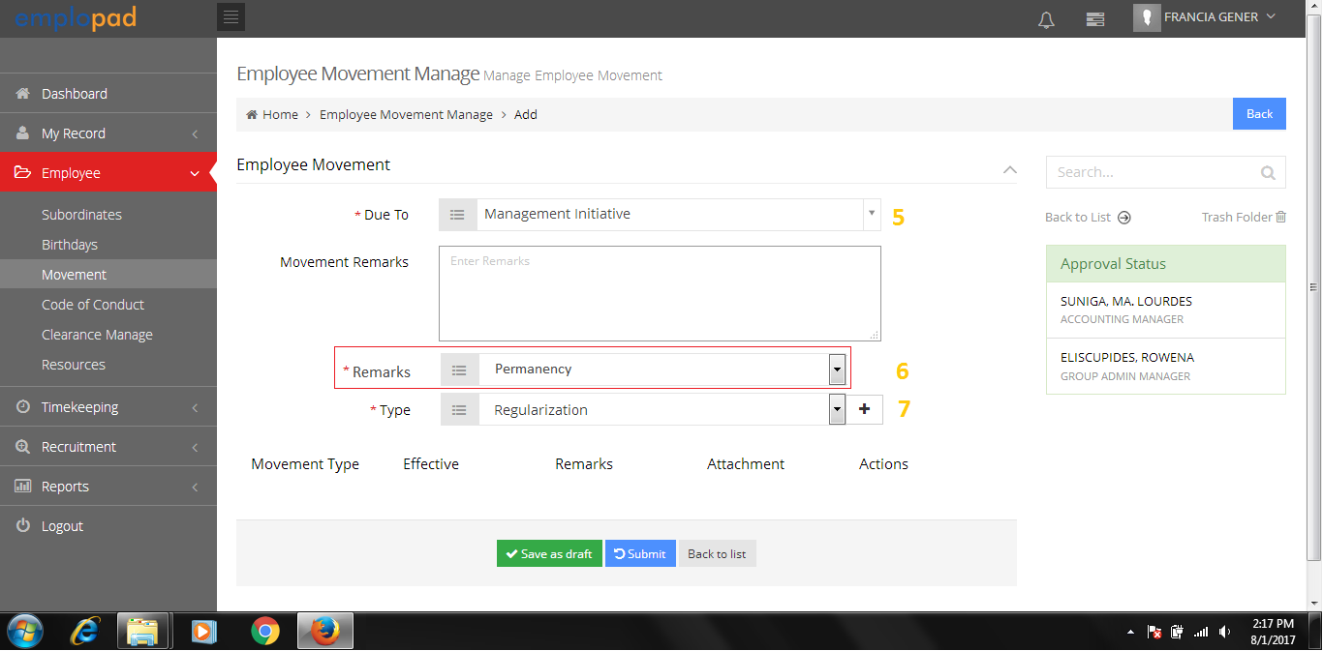

Due To:

* Employee request
* Management Initiative
* Request to add Remarks pick list that will be reflected on the Employee Movement Report Printout.
* Add master for the pre-defined movement remarks.

**A1.3** -Select the subordinates name and complete the movement details.

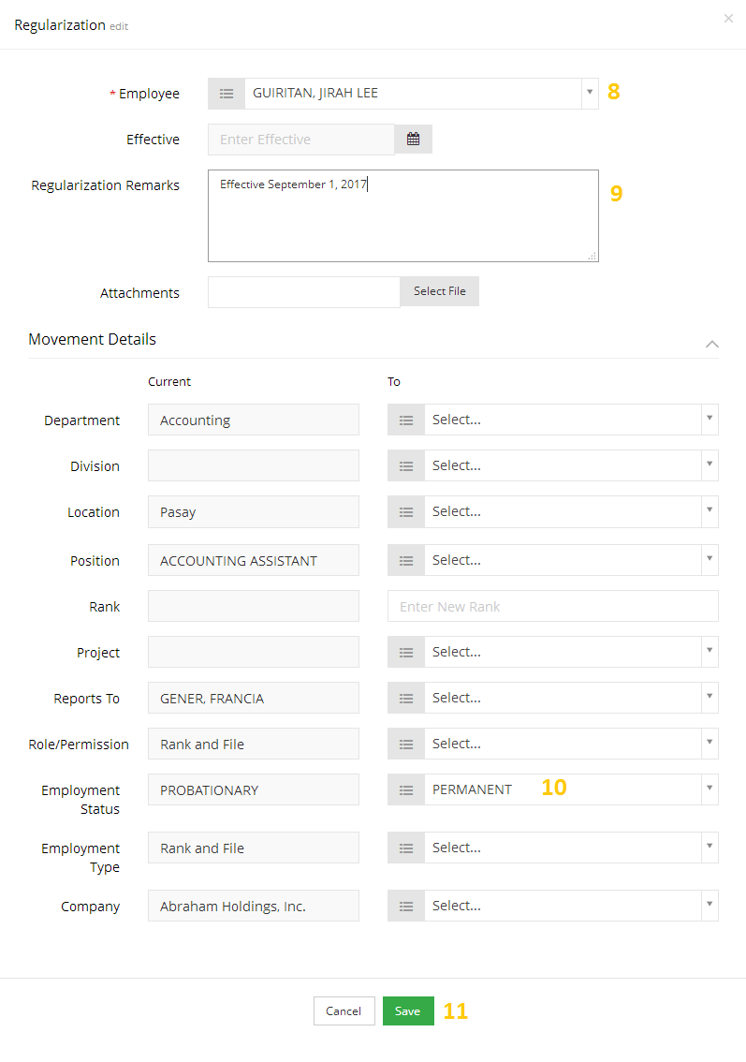

Request to remove or hide Project

Request to remove or hide Division

Employee list that will appear are his/her subordinates only.

For HR use only

Add Job Grade Picklist

Request to allow multiple attachments.

**A1.4** -System has an option to add another type of movement.

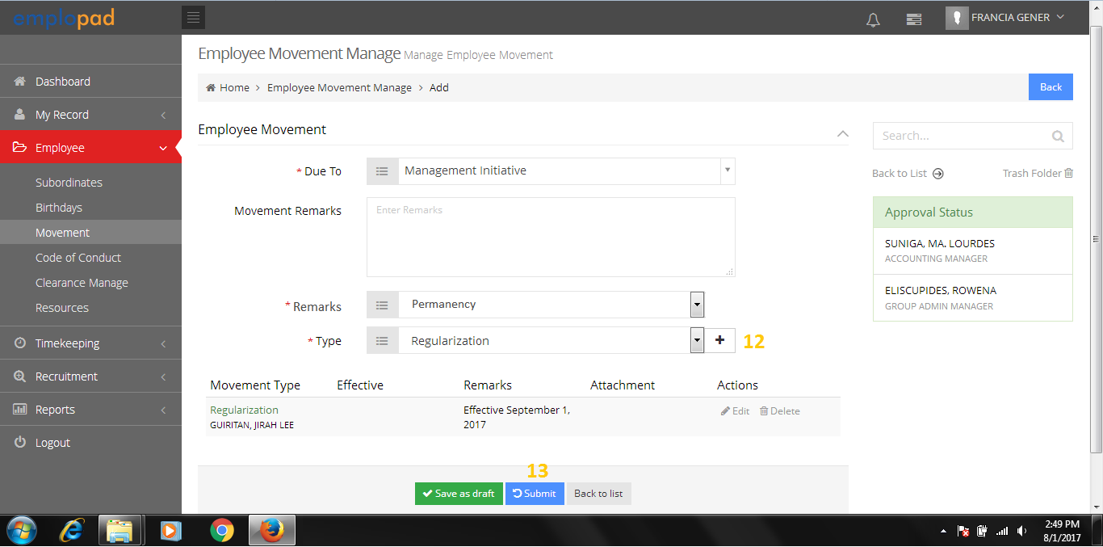

Select the movement type then click “+” button

**A1.5** -Submitted movement request will be sent to Department Head for approval.

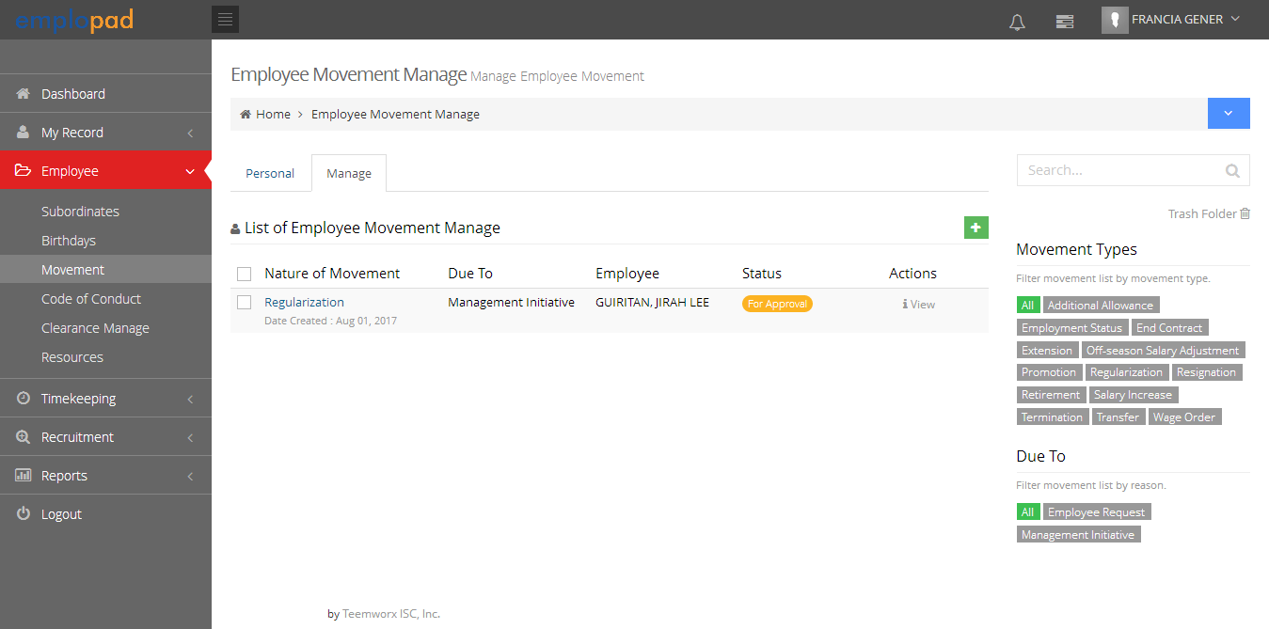

Note:

An email notification of movement request will be sent to approver 1 (Department Head).

1. **EMPLOYEE MOVEMENT APPROVAL PROCESS (Approver 1 – Department Head)**

**B1.0** – Approval thru System Notification

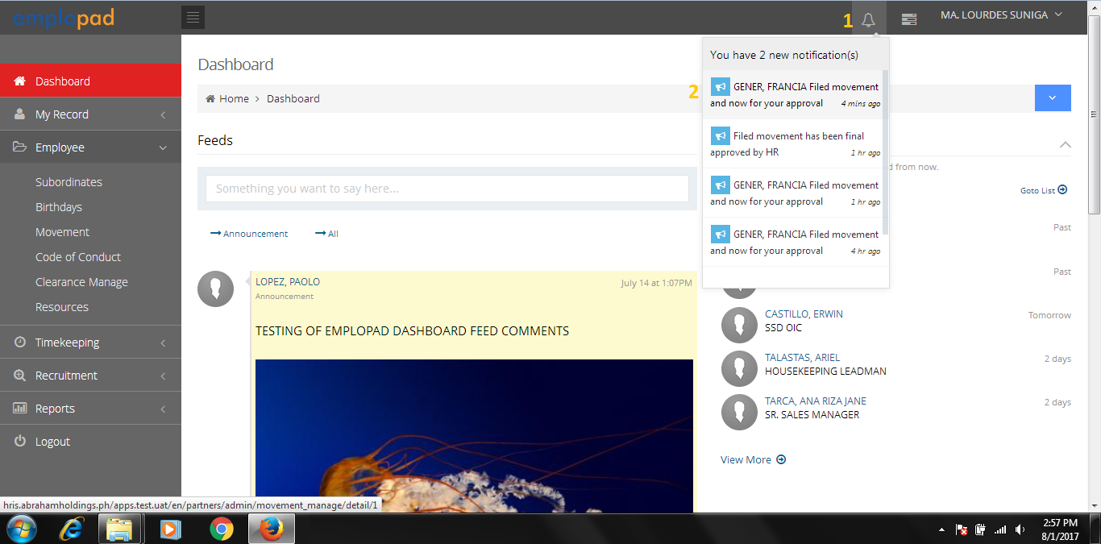

Click the notification to access the movement form.

**B1.1** – Employee Movement Form

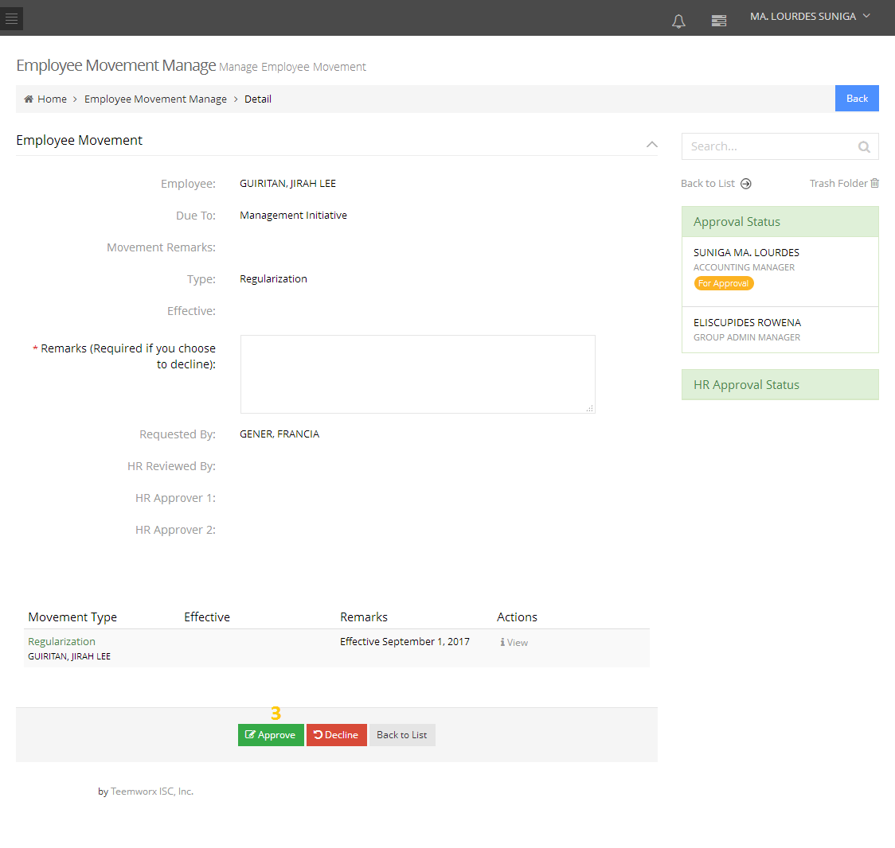

Click to view the details of movement (***See image A1.3)***

**B1.2** – Approved movement request will be sent to COO for approval.

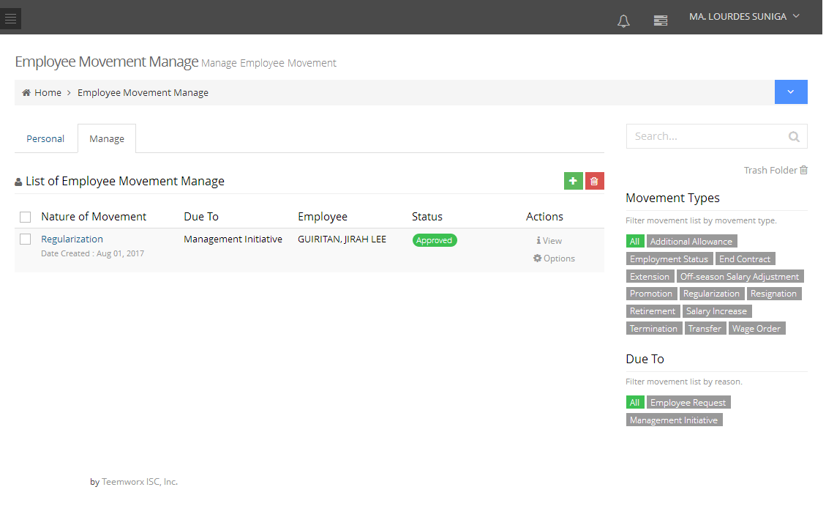

Note:

* Approved - An email notification of movement request will be sent to approver 2 (COO).
* Disapproved – An email notification will be sent to the requestor that his request was disapproved.

**OR**

**B2.0** – Approval thru Employee > Movement > Manage Tab.

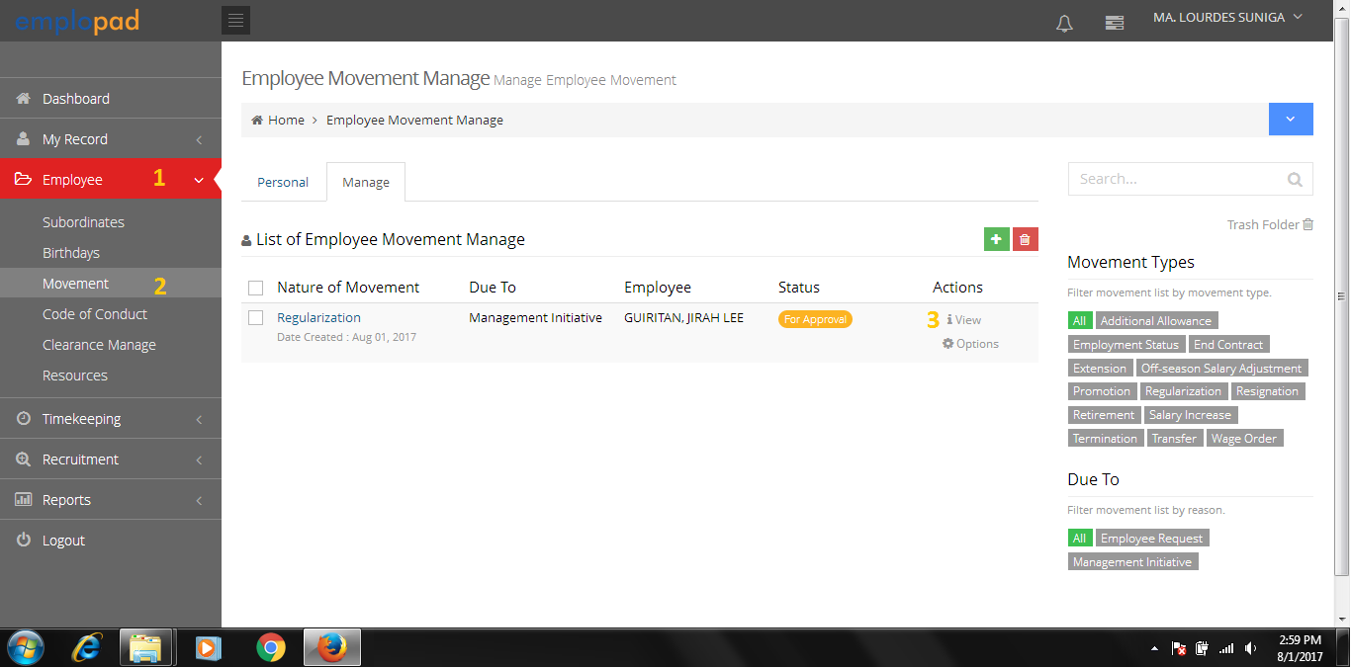

Personal Tab: will be used for the ff. movement type:

* Resignation
* Retirement

Manage Tab:

* Will be used by immediate superior for movement request of his/her subordinates.
* Can view all the movement request of subordinates.

**B2.1** – Employee Movement Form

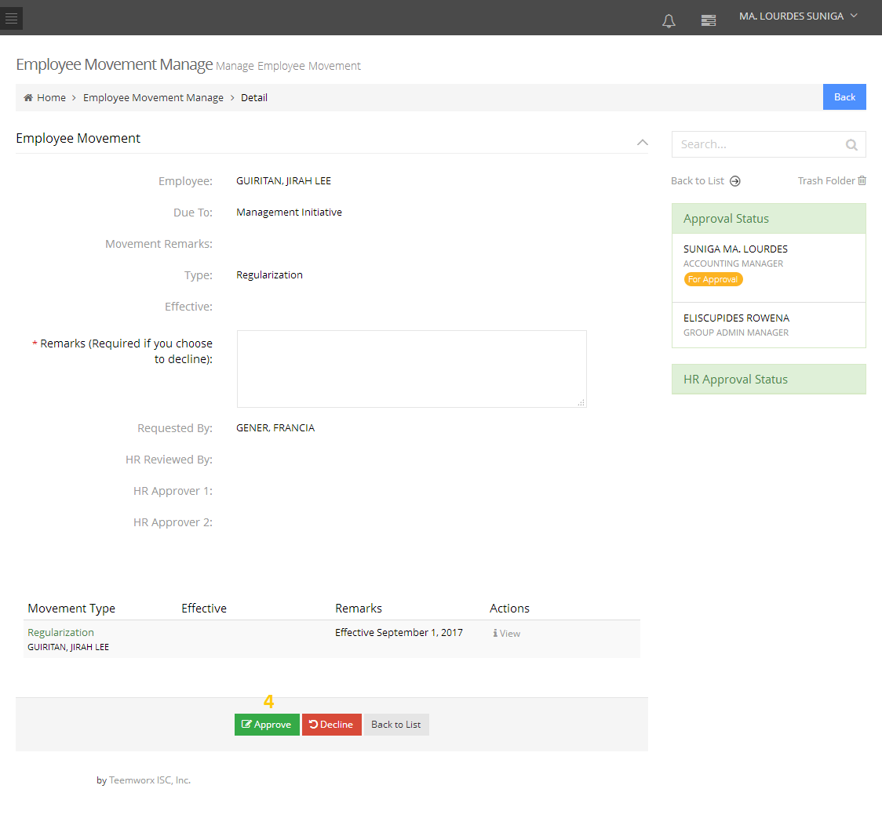

Click to view the details of movement (***See image A1.3)***

B2.2 - Approved movement request will be sent to COO for approval.



Note:

* Approved - An email notification of movement request will be sent to approver 2 (COO).
* Disapproved – An email notification will be sent to the requestor that his request was disapproved.

1. **EMPLOYEE MOVEMENT APPROVAL PROCESS (Approver 2 - COO)**

**C1.0** - Approval thru System Notification

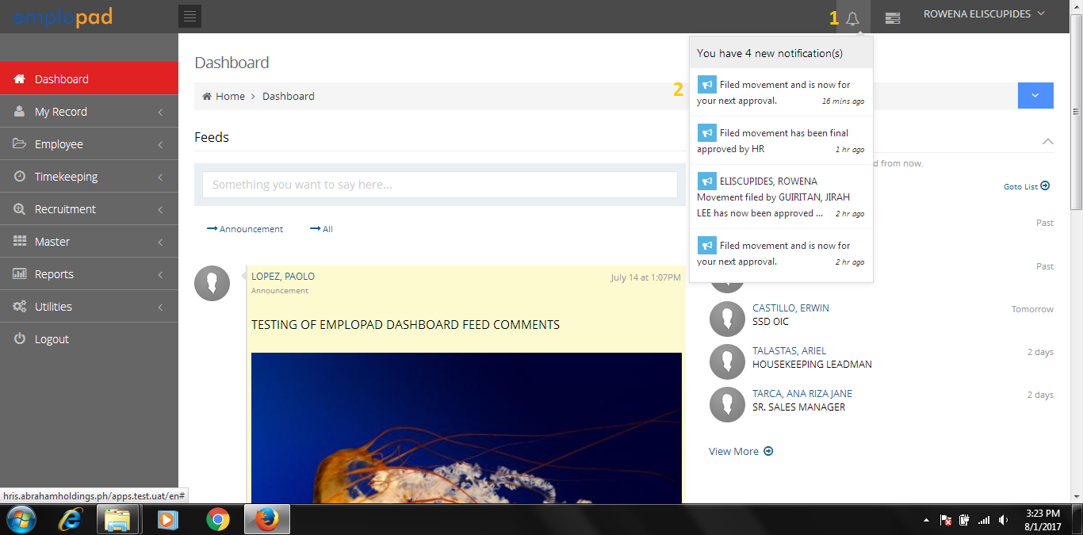

Click the notification to access the movement form.

**C1.1** - Employee Movement Form

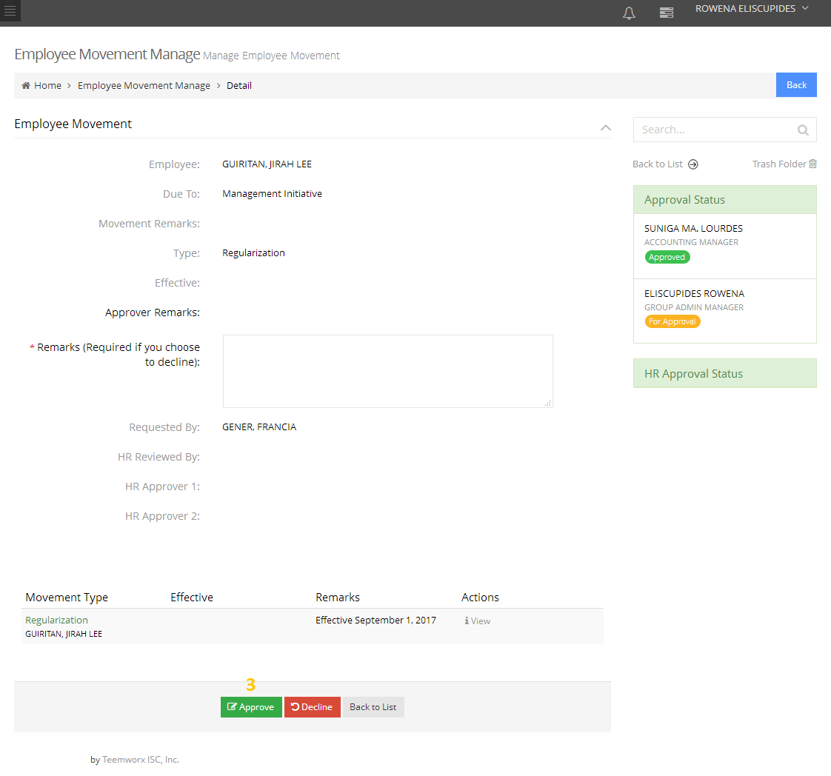

Click to view the details of movement (***see image A1.3)***

**C1.2** - Approved movement request will be sent to Assigned HRD Assistant for validation.

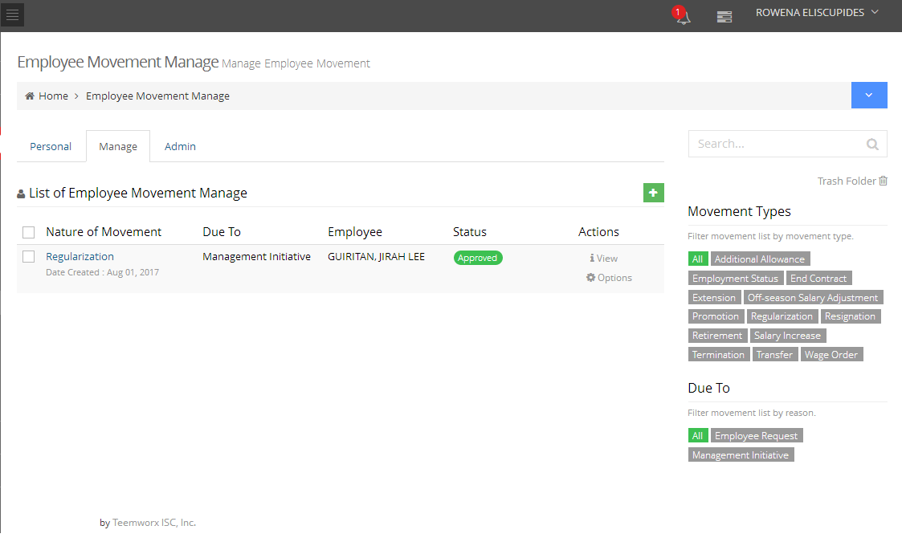

Note:

* Approved - An email notification of movement request will be sent to Assigned HRD Assistant for validation.
* Disapproved – An email notification will be sent to the requestor that his request was disapproved.

**OR**

**C2.0** – Approval thru Employee > Movement > Manage Tab.

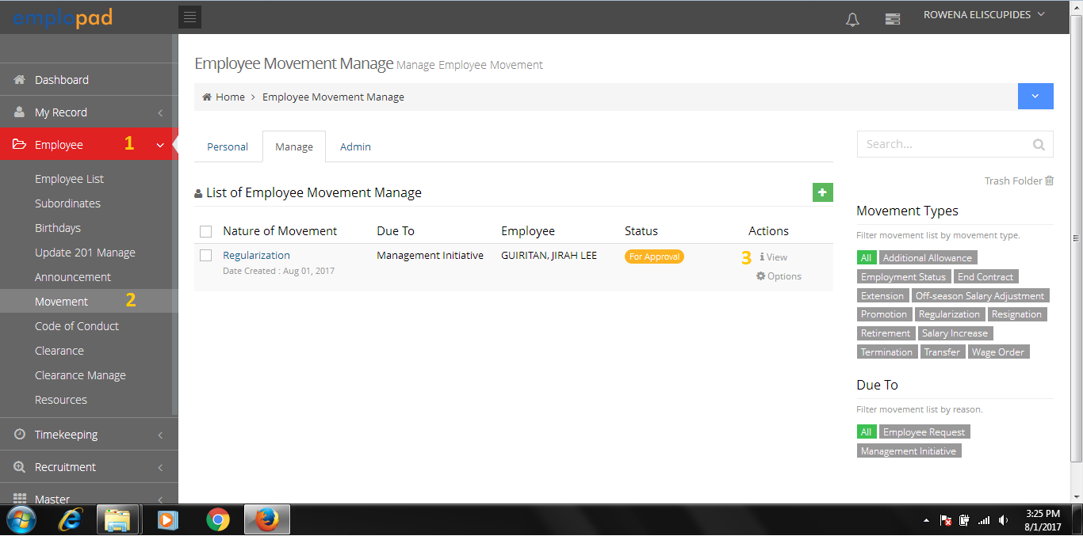

Personal Tab: will be used for the ff. movement type:

* Resignation
* Retirement

Manage Tab:

* Will be used by immediate superior for movement request of his/her subordinates.
* Can view all the movement request of subordinates.

Admin Tab:

* Can access all the movement request of all companies.
* This tab is for HR Admin access only.

**C2.1** - Employee Movement Form

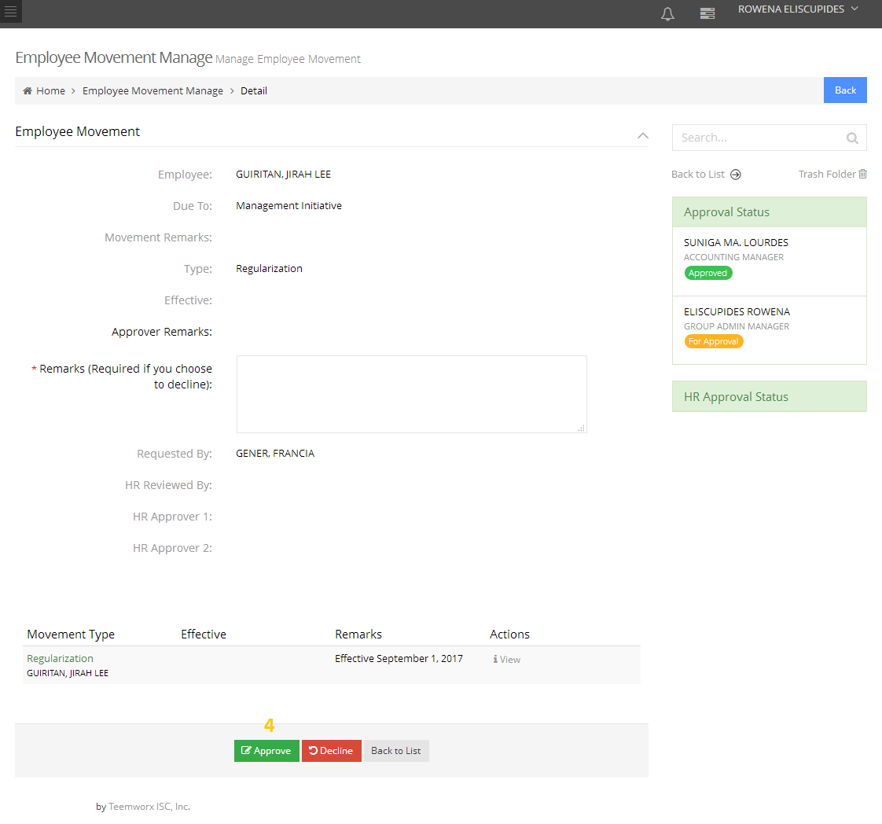

Click to view the details of movement (***see image A1.3)***

**C2.2** - Approved movement request will be sent to Assigned HRD Assistant for validation.



Note:

* Approved - An email notification of movement request will be sent to Assigned HRD Assistant for validation.
* Disapproved – An email notification will be sent to the requestor that his request was disapproved.

1. **HR Approval Process (Validation – HRD Assistant)**

**D1.0** – HR Validation thru System Notification

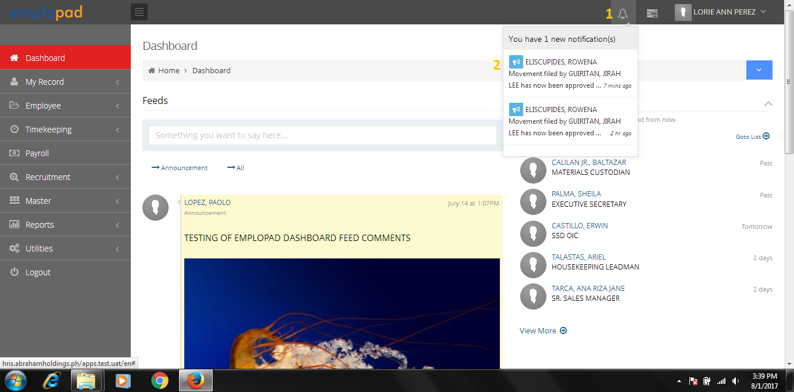

Click the notification to access the movement form.

**D1.1** - Employee Movement Form

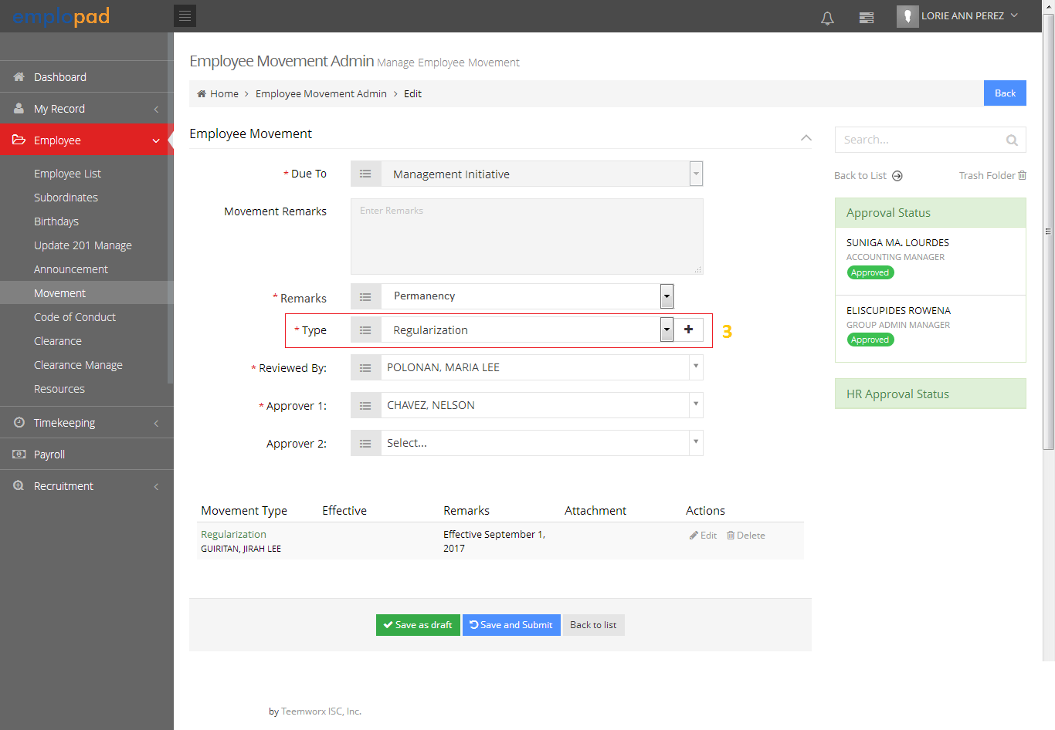

Request: for HR to have an option to add additional movement type.

Click to view, edit the details and effectivity date of movement. (S***ee image A1.3)***

HR Officer to set the ff:

* Reviewed by
* Approver 1
* Approver 2

**4**

**D1.2** – Validated and Summited movement request will be sent to HRD Supervisor for review.

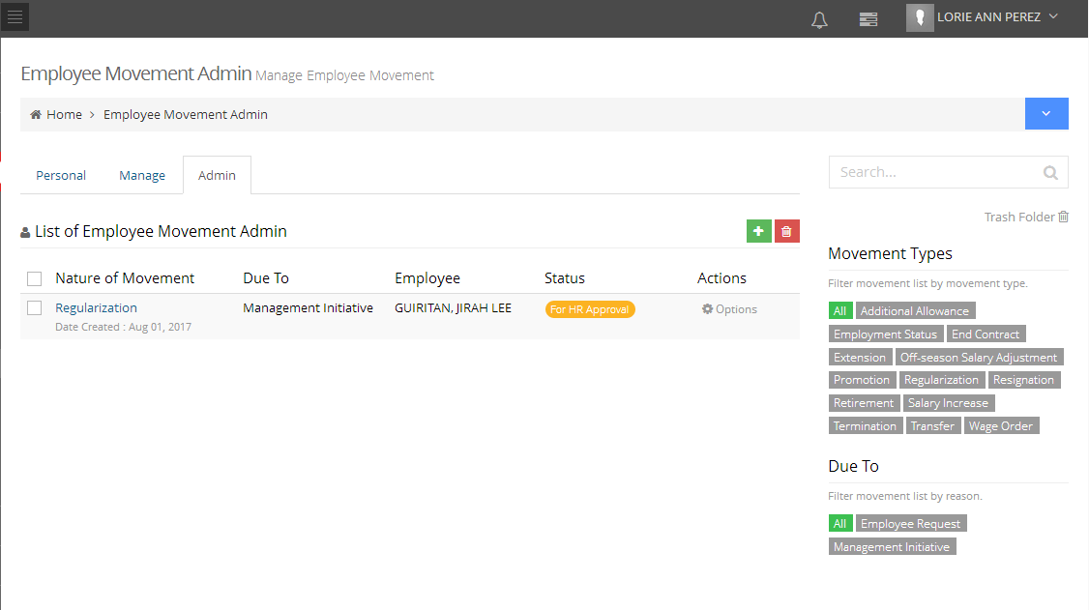

Note:

* An email notification of movement request will be sent to HRD Supervisor for Review.

**OR**

**D1.3** - HR Validation thru Employee > Movement > Admin Tab.

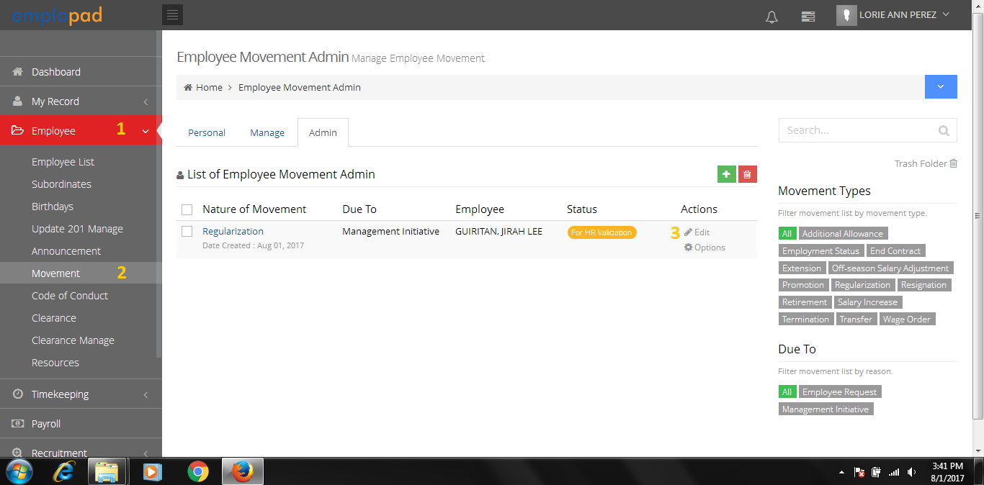

Personal Tab: will be used for the ff. movement type:

* Resignation
* Retirement

Manage Tab:

* Will be used by immediate superior for movement request of his/her subordinates.
* Can view all the movement request of subordinates.

Admin Tab:

* Can access all the movement request of all companies.
* This tab is for HR Admin access only.

**D1.4** - Employee Movement Form



HR has an option to add additional movement type.

Click to view and edit the details of movement. (S***ee image A1.3)***

HR Officer to set the ff:

* Reviewed by
* Approver 1
* Approver 2

**4**

**D1.5** – Validated and Summited movement request will be sent to HRD Supervisor for review.



Note:

* An email notification of movement request will be sent to HRD Supervisor for Review.

1. **HR Approval Process (Review – HRD Supervisor)**

**E1.0** – HR Review thru System Notification

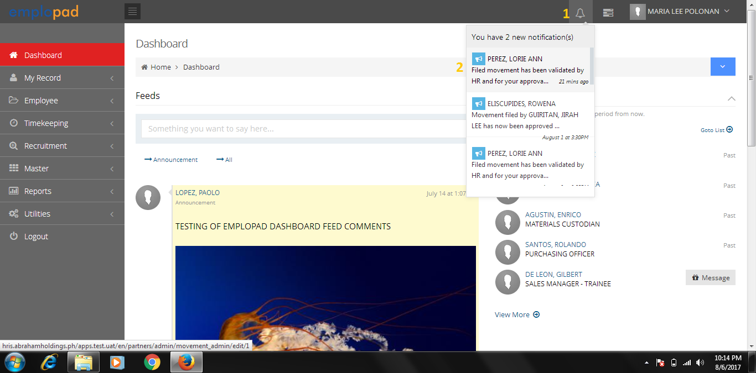

Click the notification to access the movement form.

**E1.1** - Employee Movement Form

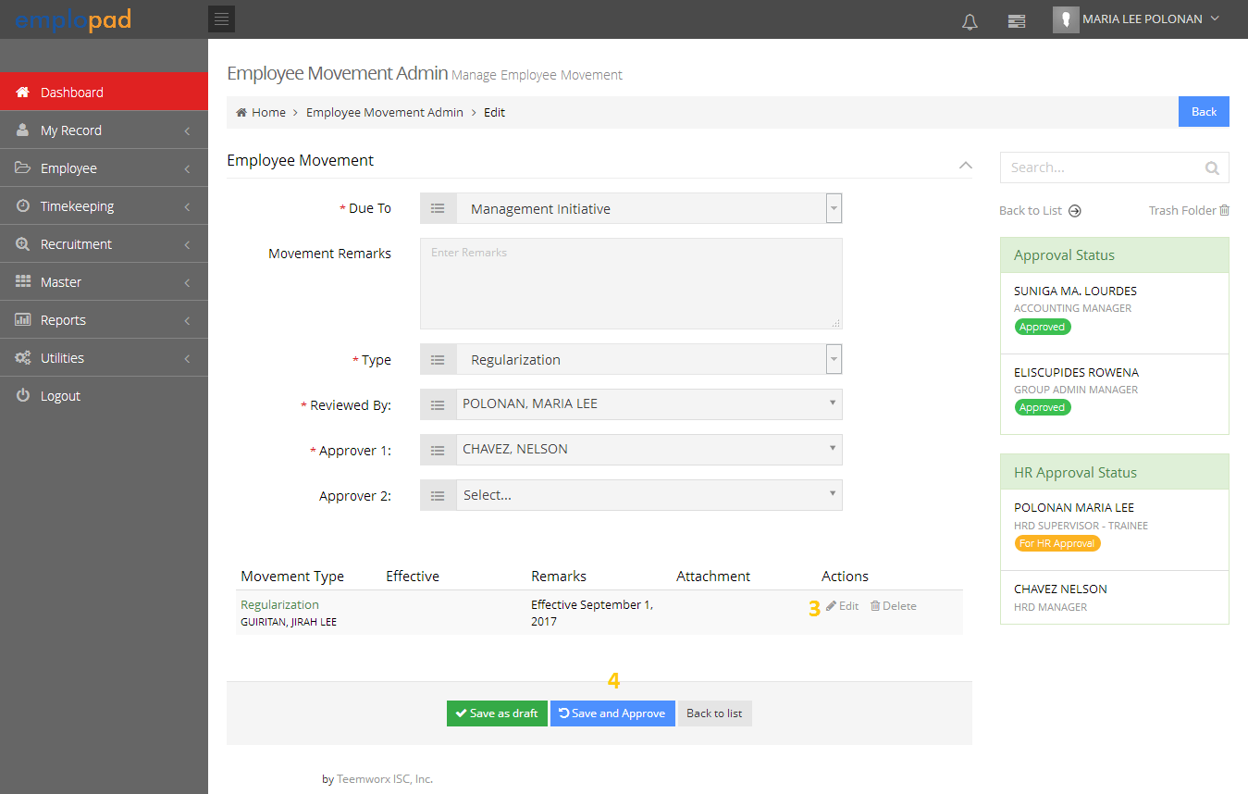

Click to view and edit the details of movement. (S***ee image A1.3)***

* Request to replace with “Approve” and “Disapprove” button.
* Disapproved movement request will go back to HRD Assistant for editing then proceed with the approval process.

**E1.2** – Reviewed and approved movement request will be sent to HRD Manager for approval.

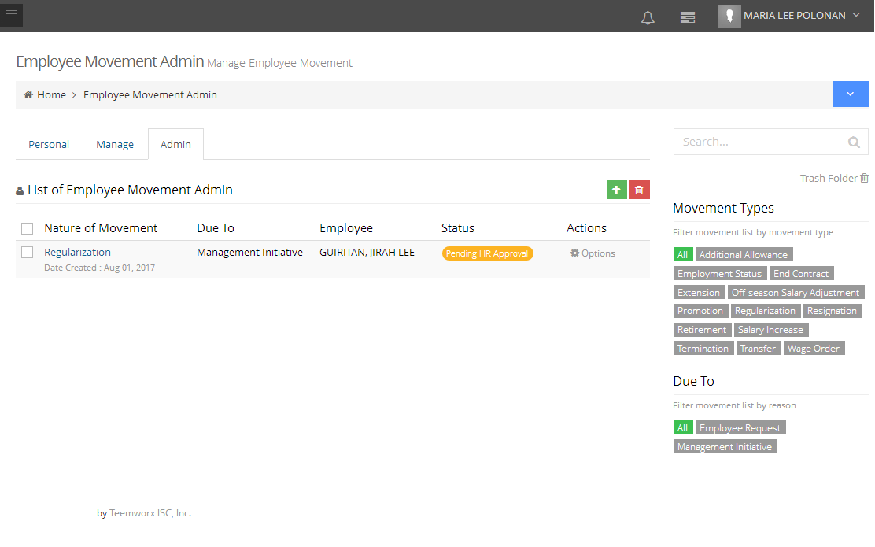

Note:

* An email notification of movement request will be sent to HRD Manager.

**OR**

**E1.3** – HR for Review thru Employee > Movement > Admin Tab.

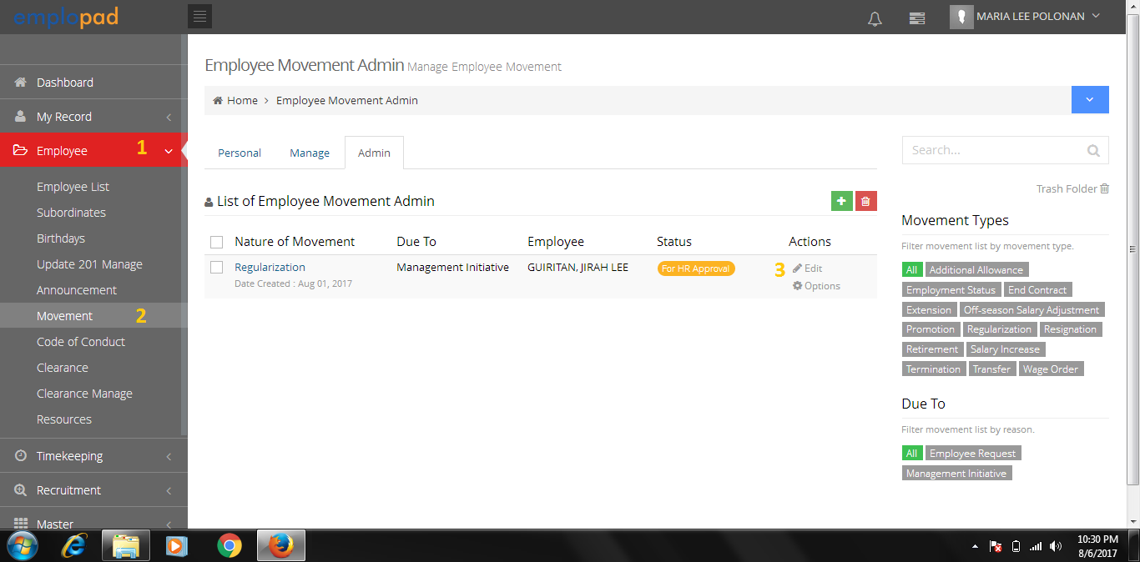

Admin Tab:

* Can access all the movement request of all companies.
* This tab is for HR Admin access only.

**E1.4** - Employee Movement Form



Click to view and edit the details of movement. (S***ee image A1.3)***

* Request to replace with “Approve” and “Disapprove” button.
* Disapproved movement request will go back to HRD Assistant for editing then proceed with the approval process.

**E1.5** – Reviewed and Summited movement request will be sent to HR Approver.



Note:

* An email notification of movement request will be sent to HRD Manager.

1. **HR Approval Process (HR Approver – HR Manger)**

**F1.0** – HR Approval thru System Notification

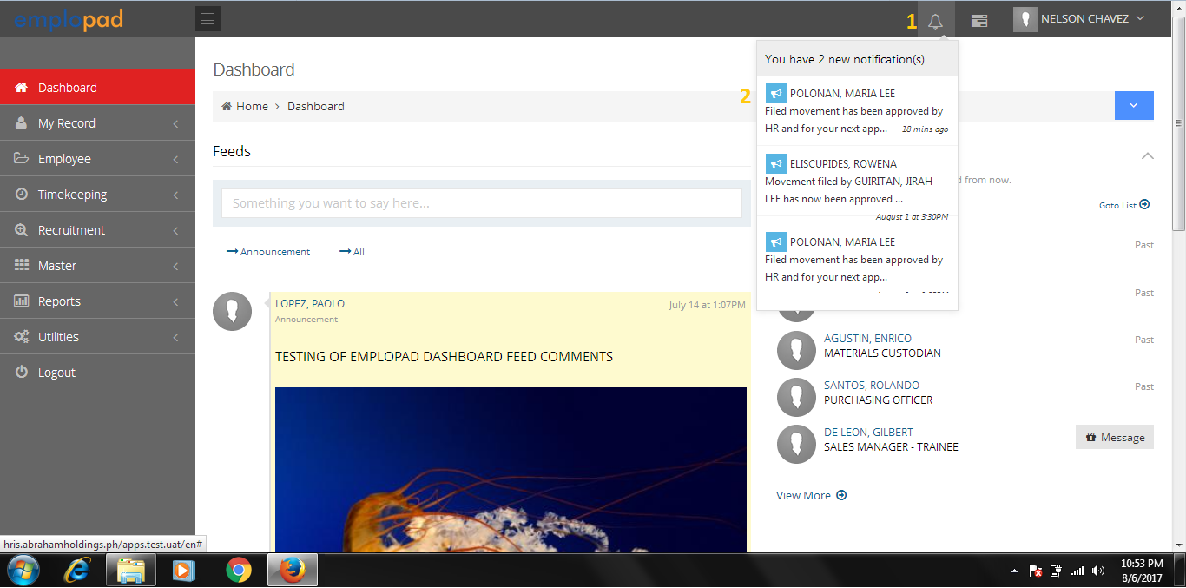

Click the notification to access the movement form.

**F1.1** - Employee Movement Form

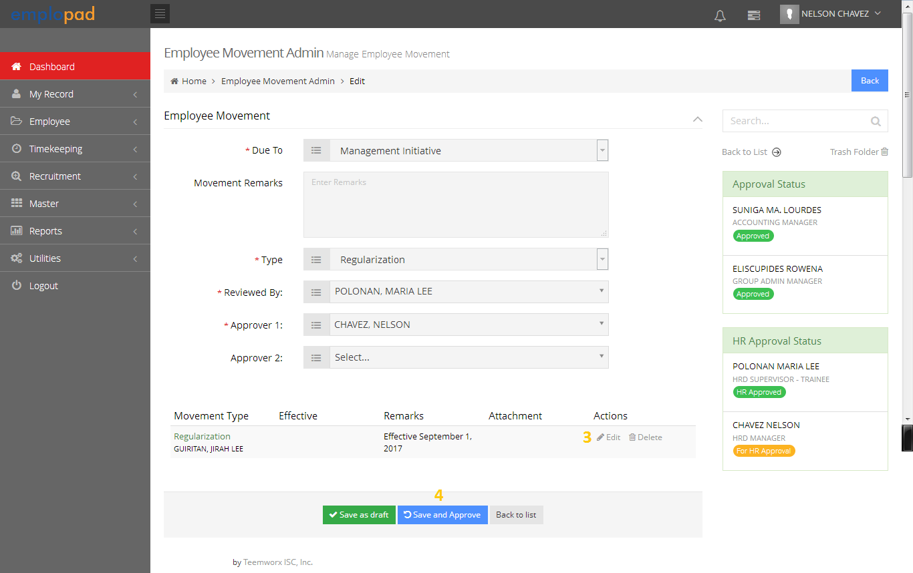

Click to view and edit the details of movement. (S***ee image A1.3)***

* Request to replace with “Approve” and “Disapprove” button.
* Disapproved movement request will go back to HRD Assistant for editing then proceed with the approval process.

**F1.2** – Approved movement request will take effect based on the effectivity date.

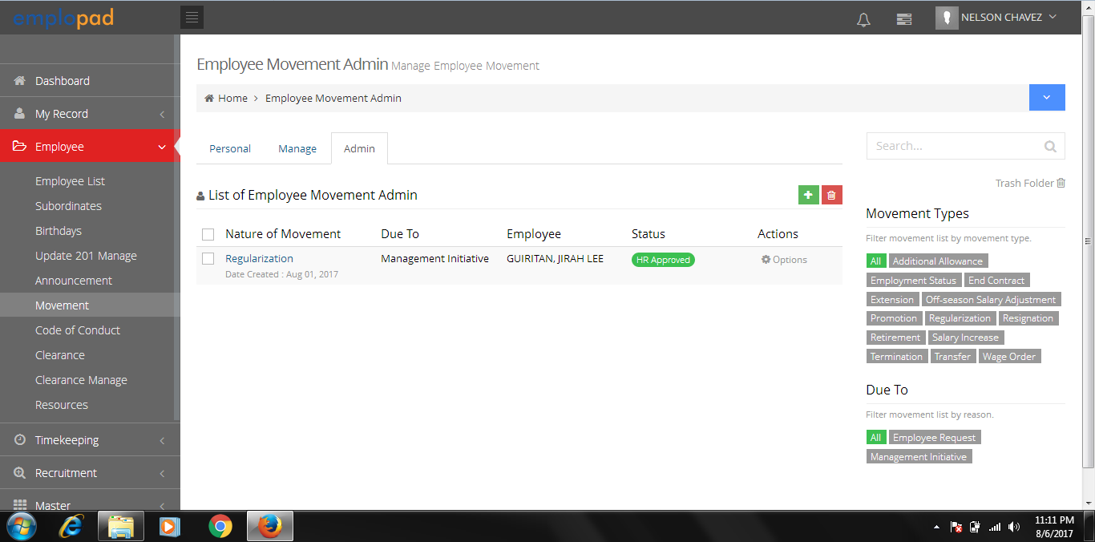

Note:

* An email notification of approved movement request will be sent to the employee and immediate superior.

**OR**

**F1.3** - HR Approval thru Employee > Movement > Admin Tab.

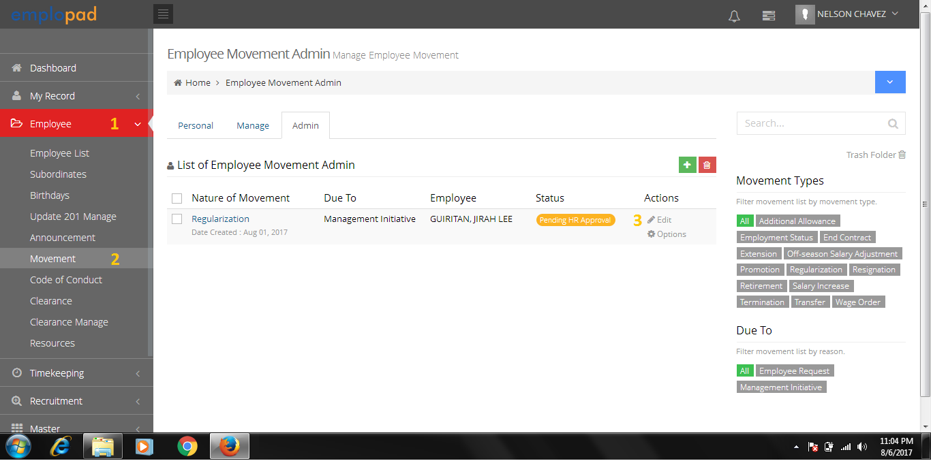

Admin Tab:

* Can access all the movement request of all companies.
* This tab is for HR Admin access only.

**F1.4** - Employee Movement Form

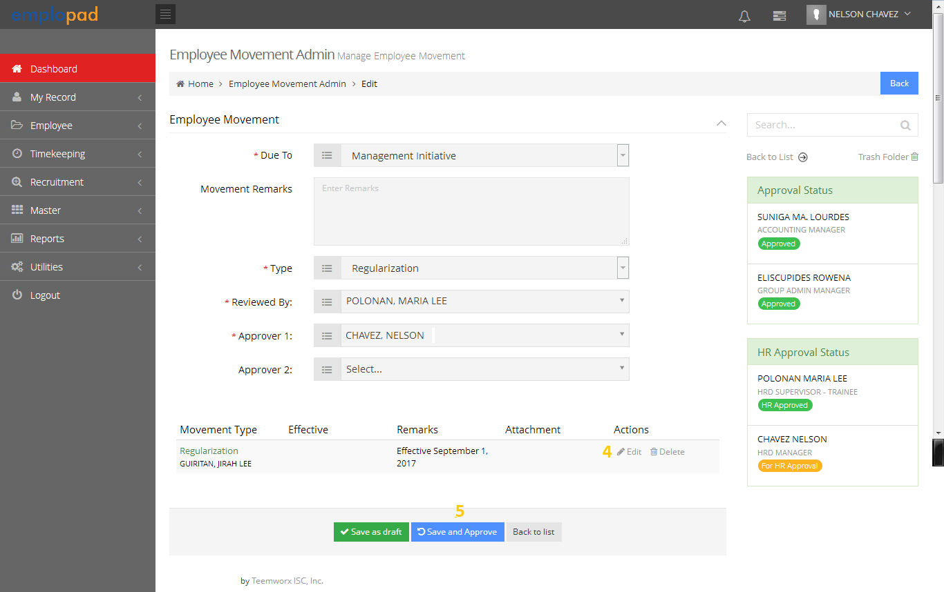

Click to view and edit the details of movement. (S***ee image A1.3)***

* Request to replace with “Approve” and “Disapprove” button.
* Disapproved movement request will go back to HRD Assistant for editing then proceed with the approval process.

**F1.5** – Approved movement request will take effect based on the effectivity date.



Note:

* An email notification of approved movement request will be sent to the employee and immediate superior.

**G. Movement Report Printing**

**F1.0** – How to print Movement Printing Repot

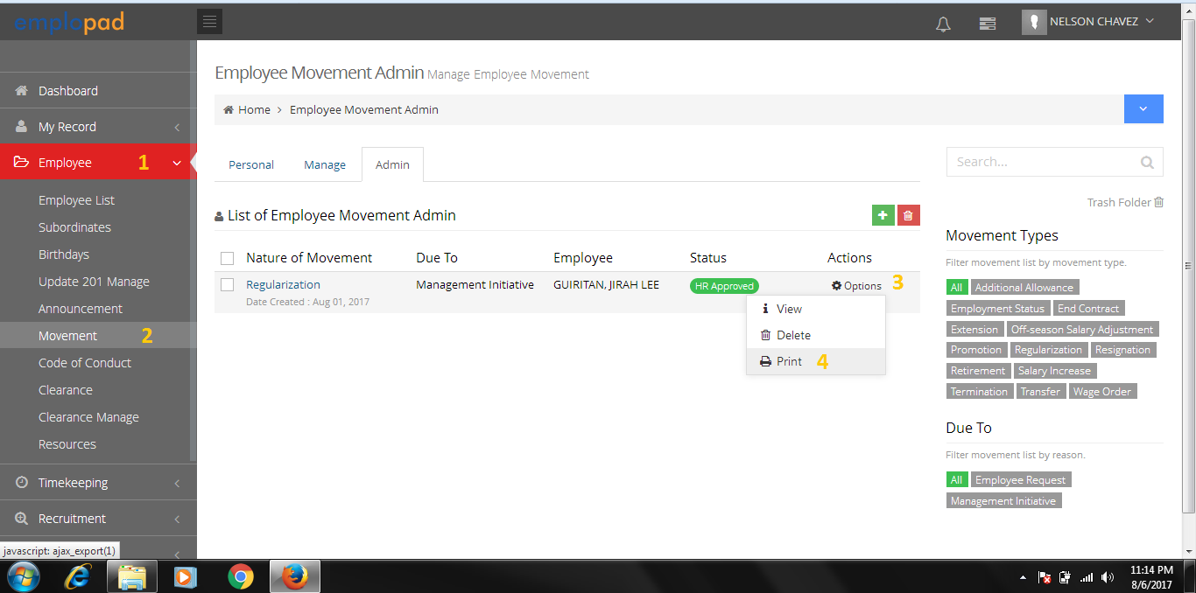

**G1.1** - Movement Report

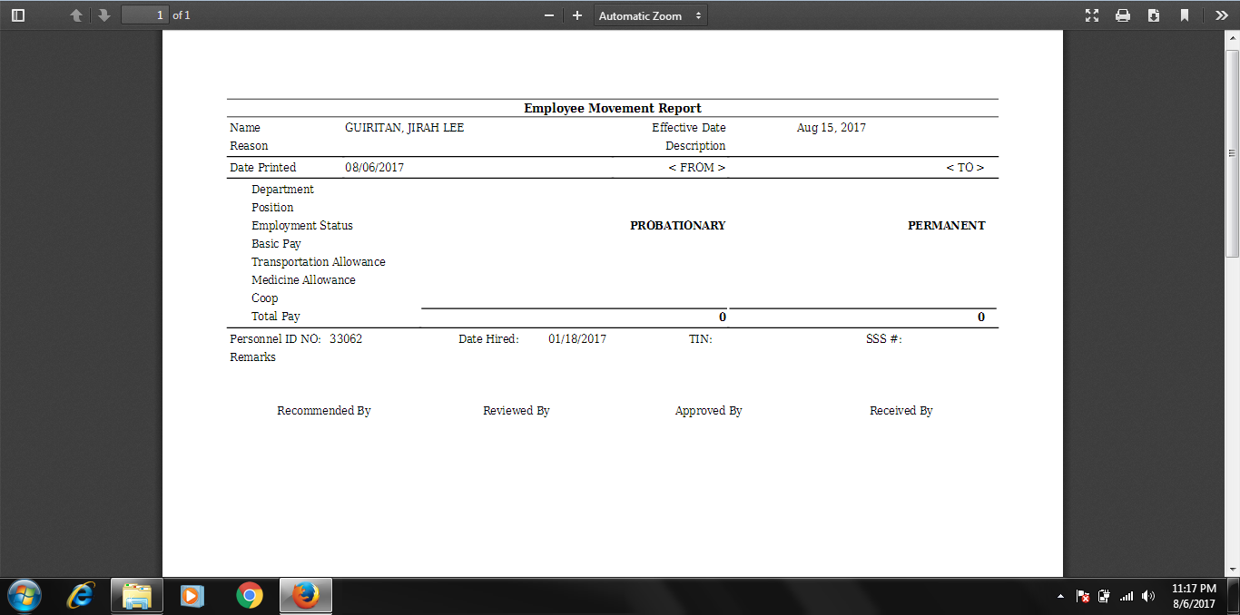

Immediate Superior Name

And Position

Movement Remarks

HRD Supervisor Name

And Position

HR Manager Name

And Position

Employee Name and Position

Current information like Department, Position, Basic Pay, etc.. must reflect on the report.

**Summary of Pending for Enhancement**

1. Movement Form

* Request to add Remarks pick list that will be reflected on the Employee Movement Report Printout.
* Add master for the pre-defined movement remarks.
* Must allow multiple attachments.
* Request to remove or hide Division
* Request to remove or hide Project
* Add Job Grade pick list

1. HR Validation

* HR to have an option to add additional movement type.

1. HR Approver (Reviewed by, Approver 1 and Approver 2)

* Request to replace with “Approve” and “Disapprove” button.
* Disapproved movement request will go back to HRD Assistant for editing then proceed with the approval process.

1. Movement Report Printout

* See details on image G1.1